**Configuring Related List on Family Expenses**

|  |  |
| --- | --- |
| Team Id | LTVIP2025TMID29041 |
| Project Name | Calculating family expenses |
| college | Kandula Lakshumma Memorial College of Engineering for Women |
| course | Computer Science  Engineering |

**Step 6: Configuring Related List on Family Expenses**

Display all related Daily Expenses record for each family member directly within their family Display all related Daily Expenses record for each family member directly within their family

1. Go to All >> In the filter search for Family Expenses >> Open Family Expenses
2. Click on New

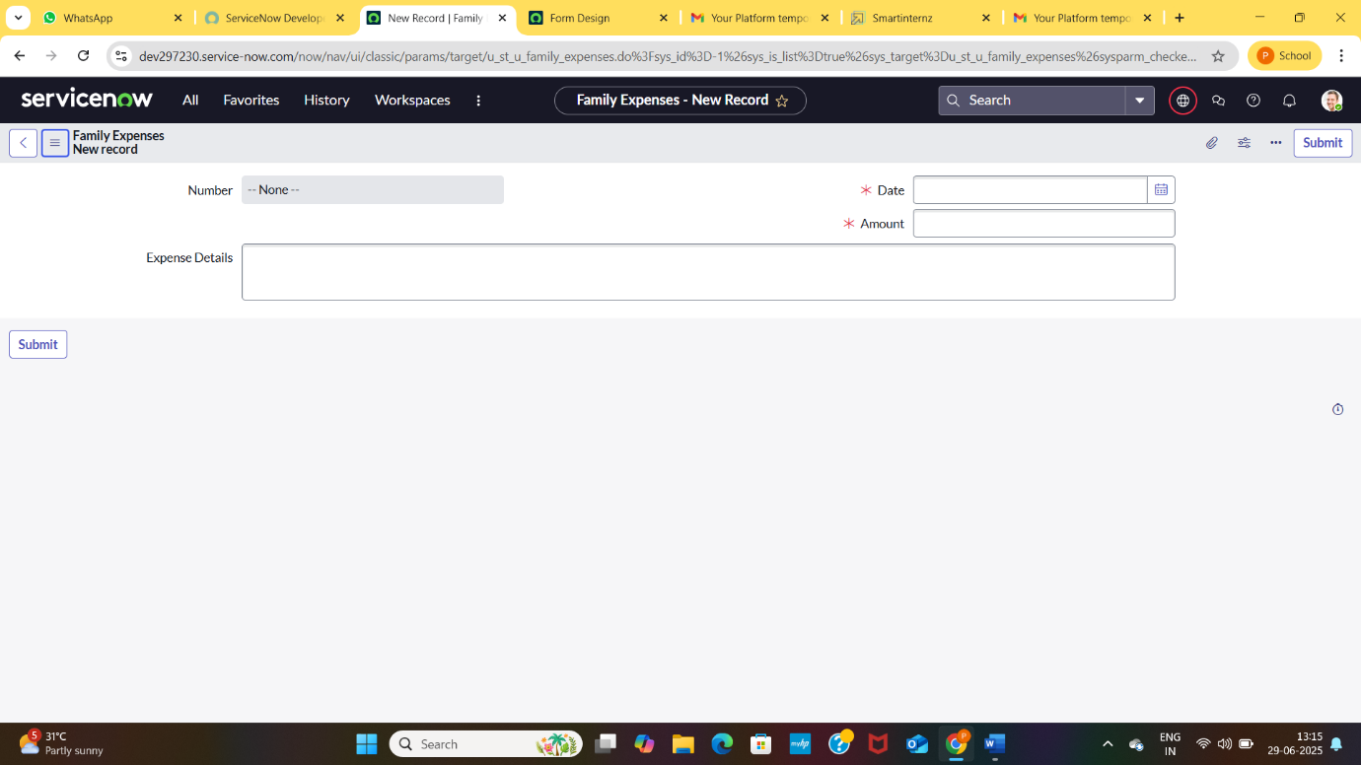

1. Go to the Header and right click there>> click on Configure >> Select Related Lists

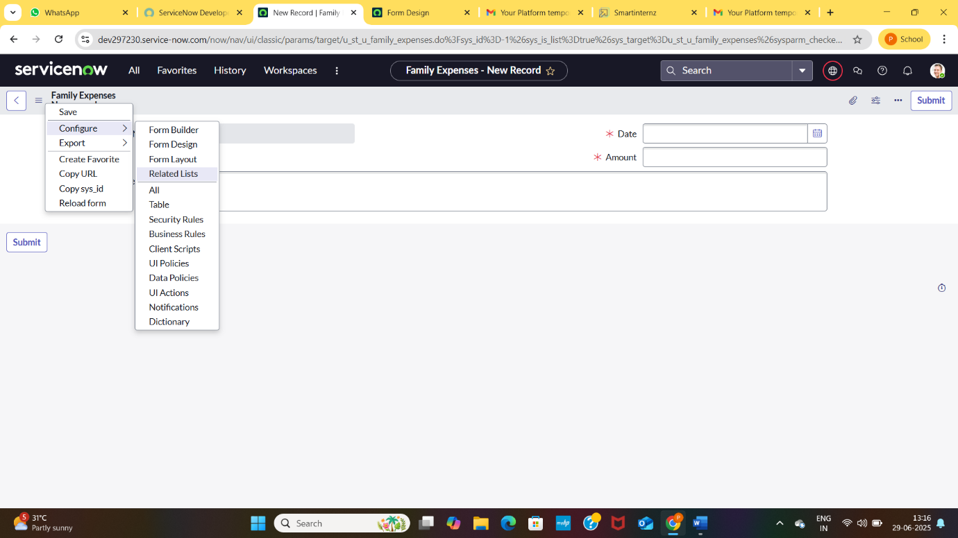

1. Add Daily Expenses to the Selected Area.

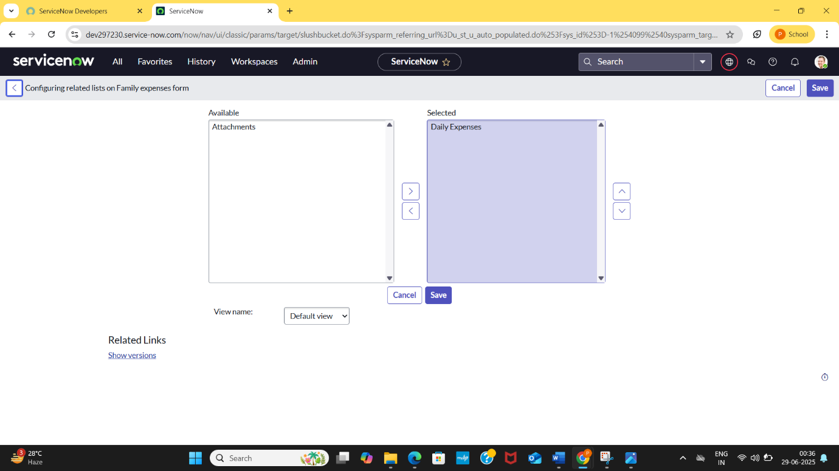

1. Click on save